# Module (CSS and CSS3)

1. What are the benefits of using CSS?

* CSS is better for the style and design of the website and creates a custom and interactive design.
* Using CSS, you can control the color of the text, the style of fonts, the spacing between paragraphs, etc.
* CSS saves time and then reuses the same sheet in multiple HTML pages.
* CSS is used to easily update and maintain.
* Better style elements and functionalities, like layout, color, fonts, and therefore the formatting and display.

1. What are the disadvantages of CSS?

* Some styles are supported and some are not.
* Anyone with access the CSS.
* CSS is a different level like as CSS, css2 and css3 supports of the different results of another browser
* CSS is not a secure style sheet
* CSS is different to display the other browser such as Chrome, opera and mozilla.

1. What is the difference between CSS2 and CSS3?

* CSS3 is the most recent and currently used.
* CSS3 is use a new selector and new elements.
* CSS3 has several new CSS properties. It supports animation.
* The selectors in CSS3 has increased while CSS1 and CSS2 only had simple selector.
* CSS2 is not a specific use as a web layout.
* CSS2 still has browser extension issues.
* CSS3 has complete support for almost all recent web browsers.
* CSS3 has compatibility with external font styles through google fonts. It was not possible with earlier CSS1 and CSS2.
* CSS3 recent add-ons are border-radius, box-shadow, flex-box and CSS grid.

1. Name a few CSS style components

* List of Components

1. Selector: element name, id name and class name
2. Property: width, height, background-color, color, border, text-align and position
3. Values: Define property or values
4. What do you understand by CSS opacity?

* CSS opacity is a property that allows you to adjust the transparency of an HTML element. It can be applied to any HTML element, including text, images, and background colors.
* The value of opacity lies between 0.0 to 1.0
* When the value is low, it is transparent and value is high, it is not transparent.
* Example:

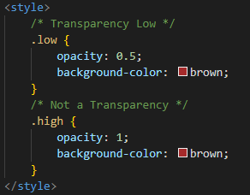

1. How can the background color of an element be changed?

* To change the background color of an element in CSS.
* Use the background-color property.
* From any value

1. Hexadecimal value
2. RGB value
3. HSL value
4. RGBA value
5. HSLA value

* Example:

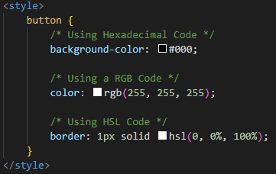

1. How can image repetition of the backup be controlled?

* This background-repeat property is used for the image not to be repeated.
* This is a two-value property

1. repeat: default (both sides horizontally and vertically fixed)
2. repeat-x: horizontally fix
3. repeat-y: vertically fix
4. no-repeat: not repeat

* Example:

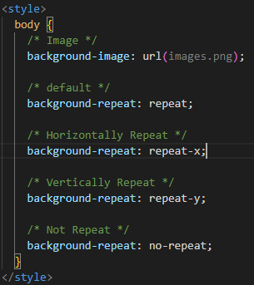

1. What is the use of the background-position property?

* The background-position property uses the background image's horizontal and vertical position fix.
* List of value in property

1. top
2. bottom
3. center
4. left
5. right

* Example

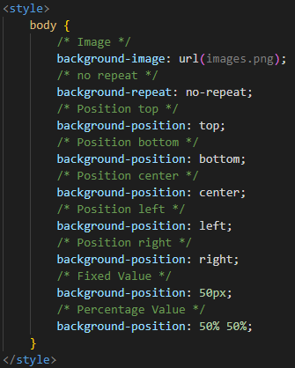

1. Which property controls the image scroll in the background?

* The CSS property that controls the image scroll in the background is called background-attachment
* The types of two property in background-attachment

1. scroll: default value
2. fixed: fixed value

* Example

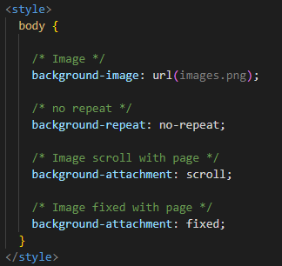

1. Why should background and color be used as separate properties?

* Separating background and color into different CSS properties mor creative a webpage.
* Example: when it is a light page it uses dark text color and when it is a dark page it uses light text color.

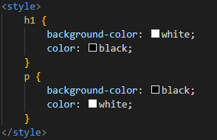

1. How to center block elements using CSS1?

* There are two ways of centering block level elements.
* The properties margin-left and margin-right to auto and width to some explicit value.

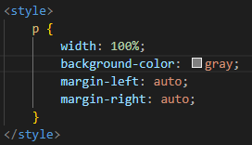

1. How to maintain the CSS specifications?

* The CSS specifications are maintained by the World Wide Web Consortium (W3C)
* The latest version of CSS is CSS3
* It makes easier to class and id special style code by CSS Specification.
* Use comments in your CSS code then find the other developers to understand your code and easily maintain.

1. What are the ways to integrate CSS as a web page?

* There are three ways of integrate CSS

1. Inline
   * Inline style is directly defined by the html element using the style attribute.
2. Internal
   * Internal style is defined the head section of an HTML document.
3. External
   * External style is a create a new CSS file and the linked the HTML file.

* Example:

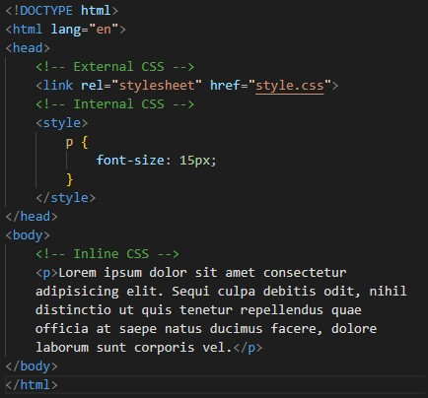

1. What is embedded style sheets?

* HTML document using the <style> element that is called embedded CSS. This tag is placed inside <head>...</head> tags.

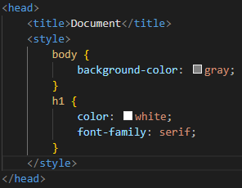

1. What are the external style sheets?

* External style sheets are created in separate documents with a .css extension.
* Multiple webpages can use the same link to access the stylesheet.
* External style is a create a new CSS file and the linked the HTML file.
* Example: You can create a file named style.css and link it to an HTML document head section.

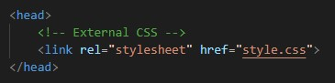

1. What are the advantages and disadvantages of using external style sheets?

* Advantages: Using, the styles of multiple documents can be controlled from one file.
* You can use the same .css file for multiple pages.
* Classes can be created for use on multiple HTML element types in many documents.
* In complex situations, selector and grouping methods can be used to apply styles.
* Disadvantages: In order to import style information for each document, an extra download is needed.
* The external style sheet is loaded, it may not be possible to render the document.

1. What is the meaning of the CSS selector?

* CSS selectors select HTML elements such as id, class, type, attribute etc.
* There are five different types of selectors in CSS.

1. Element Selector

* Syntax: p{color: red}

1. Id Selector

* Syntax: #p{color: red}

1. Class Selector

* Syntax: .p{color: red}

1. Universal Selector

* Syntax: *{color: red}

1. Group Selector

* Syntax: p, h1 { color: red}

1. What are the media types allowed by CSS?

* List of media types

1. all
2. print
3. screen
4. speech
5. What is the rule set?

* A CSS rule set contains one or more selectors and one or more declarations.
* The selector, which in this example is h1, points to an HTML element.
* In this example, the declaration is blue and text-align: center styles the element with property and value.
* The declaration, which in this example are color: blue and text-align: center style the element with a property and value.

1. Create Layouts

* A create a layout of website such as header, menu, content and footer.
* Different layouts can be created by using div tag and use CSS property to style it.

